**INHA UNIVERSITY TASHKENT**

**DEPARTMENT OF CSE & ICE**

**FALL SEMESTER 2018**

**SOC 3010 - OPERATING SYSTEM**

**TERM PROJECT REPORT**

Fticket.uz – Ticket Reservation System for Football Matches

**Submitted by**

**Student Names Student ID**

**1. Shokhrukhmirzo Mirzakhmedov u1610230**

**2. Abbosjon Kudratov u1610001**

**3. Boburjon Borataliev u1610053**

**4. Aziz Riskulov u1610037**

**5. Azizbek Avazov u1610030**

**6. Mukhammadrasul Mukhtorov u1610156**

**Group : 001,003 Junior**



|  |
| --- |
| Fticket.uz – Ticket Reservation System for Football Matches  **CONTENTS**  **SECTION 1 :** **Abstract 4**  **SECTION 2 :** **Introduction 5**  **SECTION 3 :** **Project Overview 6**  **SECTION 4 :** **Requirements definition 11**  **SECTION 5 :** **Project Design & Implementation 14**  **SECTION 6 :** **Results & Discussions 15**  **SECTION 7 :** **Conclusion 17**  **SECTION 8 :** **Future Work 17**  **SECTION 9 :** **References 18**  **SECTION 10 :** **Project Team 19** |

**TITLE OF THE PROJECT:**

**F-Ticket.uz – TICKET RESERVATION SYSTEM FOR FOOTBALL MATCHES**

**PROBLEM STATEMENT :**

Nowadays, football is one of the most popular types of sport in the world. Namely, Population of Uzbekistan have a great interest in this sport. Thousands of citizens visit to different stadiums to watch live soccer matches. However, there are some problems in the ticket reservation system of stadiums.

The problems are that ticket sale and reservation are not automated. Citizens of Uzbekistan are really busy and it is really hard to find time to go and buy tickets months or weeks before and because of that a lot of people purchase tickets just before the match starts, they have to wait several minutes (sometimes hours) in queues. It is really hard task for ticket offices to handle such long queues which consist of thousands of people. By some estimations, 30% of football fans skip the starting event sometimes halftime of matches waiting in queues for tickets.

Observing the problem and the statistics above, we came up with a final conclusion to make an online ticket reservation application which would be an optimal solution for the problems above.

**ABSTRACT :**

This Online Ticket reservation platform will address several problems with one common solution of integrating it to the organizational system structure of football matches. Using the simple way of selling the tickets for football matches usually leave people with many obstacles that they face just in order to enter the stadium. Given the information as appropriate, someone will be able to shorten the time spent for the registration process and save efforts costing a lot of money and human resource labor.

This project will develop an application that can provide information about the upcoming events – football matches, the location of stadiums where the matches will take place and specific information about each of these stadiums, availability of seats along with their prices. The client-server model architecture will be implemented for the connections between the sides. Namely, there will be the single server, handling all the requests from many clients – customers, as well as many authorized ticket sellers and admins.

So the scope of this project is whole system of Uzbekistan’s stadiums and football teams. Multiple users/customers/football fans will be able to make request to the server to buy tickets for available seats. The authorized ticket sellers are the officers who will be based in stadiums of teams. And consequently there can be many ticket selling offices too. The role of administrators is to specify the prices of tickets for matches. The admins will have right to add events as well.

Following diagram shows the working model of the platform – the server responds to many clients simultaneously as well as many ticket sellers and admins:

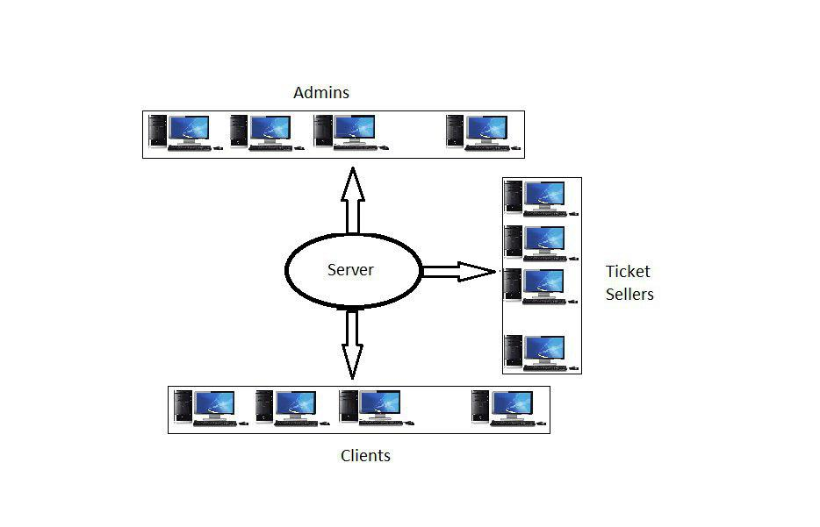

**INTRODUCTION**

Buying tickets in person is by far the easiest way to purchase tickets, however many fans live outside of the area, or cannot get down to the stadium to purchase tickets in advance due to work or some life conditions. The main aims of the project are to create a reliable and easy to use system, which will simplify the purchasing of tickets. Our project Fticket.uz – Ticket Reservation System for Football Matches is ipc-based application where football fans can check the availability of dates, seats and reserve football tickets instantly. Our team has carried out following tasks on this project.

1. On Graphical User Interface
2. On Database
3. On IPC

On Graphical User Interface we have designed not complicated but simple user interface and user will use system very easily. This displays available tickets and seats sector by sector and matches. Log in page for users and registration. Moreover there is window also for admins to help to track with available tickets and seats and to modify and add matches. This is also for multi admins with log in page.

On Database part we have created special database system for project. Following data are stored:

1. User Information
2. Ticket Information
3. Stadium Information
4. Admins Information
5. Matches Information
6. Payments Information

On IPC part we have used socket programming to communicate the users with the server.

In Uzbekistan, there is not this kind of online ticket reservation services and football fans have to go to stadium and wait in a big queue to get a ticket. This project is very suitable for our countries football fans. We have add following some useful services for users to satisfy their requirements.

1. Customers can check availability the seats and dates.
2. Customers can reserve football tickets from distance.
3. Admin of the program can add, modify and check the available matches and seats.
4. This is also works for official ticket sellers to sell their tickets in stadiums.

**OVERALL PROJECT OVERVIEW :**

This online ticket reservation system will be a platform with a database containing information about all the football matches in UFF League (Uzbekistan Premier League), Stadiums, availability of tickets for seats and prices. When system starts there will be option to log in as an administrator and authorized ticket seller. In the startup screen there will be displayed the schedule of upcoming events/matches for which tickets available. If the client wants to buy/reserve the tickets he has to first choose for which match.

After that only available seats in different sectors with different prices will be shown for chocse. Once the client wants to proceed with the payment system and pays the specified amount the reservation system will confirm it and that seat number will become reserved, so that no other user can buy ticket for it.

Admin will have a right to access and update the database of game events.

For every match there will be starting time and 1 hour before that time the reservation system will restrict ticket selling.

Authorized ticket seller logs in using special password and can also see the available seats with prices. The sellers will usually operate near stadiums in ticket selling offices so that clients (football fans) can buy the tickets from them. The same procedure applies and the reservation system updates the availability in the database so that clients who want to buy online will see the updated real-time information.

We have generated separate diagrams for each Client Side and Server side, because the main application deals with network sockets when using the connection between the server and customers, server and ticket sellers.

In the diagrams below we clearly specified the 2 main sides that the platform consists of: server side and user side.

The server side can respond to all the queries from customers and authorized ticket sellers at the same time. In order to synchronize the transactions we use the semaphores along with the network sockets for IPC.

The user side is divided further into ticket seller and customer modules. And the ticket seller is different from customer module.

**Module: Customer**

Function 1:

1. Get events from DB
2. Send to client sides

Function 2:

1. Select stadiums from DB
2. Select all seats which have attribute available=true;
3. Display seat number, row number and sector number
4. Select the seat

Function 3: **Arguments**(sector_id, seat_number,row_number)

1. Check availability of the seat

If seat.available = true -> continue

else -> print “sorry, ticket for this seat already sold out”, go back to Function2 -2

1. Send cost of ticket
2. Go to Payment() function;

**Module: Ticket Seller**

Function 1:

1. receive as argument inputted login & password

2. compare arguments with all login, passwords in Database table Admins

3. if login & password matches → go to start screen, else → go back(display “wrong login or password, please try again”

4. start screen→ display options:

Function 2:

1. Display list of stadiums
2. After stadium is chosen-> location= stadium.location
3. Choose all events lists from DB where stadium = current stadium

Function 3:

1. Choose all available seat number & display the prices
2. After customer chooses the seat number go to Payment();

**Server side**

**Module: Admin**

1. receive as argument inputted login & password

2. compare arguments with all login, passwords in Database table Admins

3. if login & password matches → go to start screen, else → go back(display “wrong login or password, please try again”

4. start screen→ display options:

1.edit stadiums

2.add events/matches

5. if option is 1 → go to function editStadium();

display display list of stadium names;

select stadium name;

display options: add rows, delete rows, set price

if option = set price → display selection of rows and seat number

to save the changes → require password confirmation

if this inputted password = current password → save changes to Database & exit();

6. if option is 2 → go to function addEvent();

addEvent(){

1.input the names of teams in order

2.select the 1st team name → select the stadium of this team

3.add event to the stadium

4.set the date of the match

5.confirm password: if passwords match → save & exit();

|  |
| --- |
| Amount()  Price()  Type()  Sector() |

ShowEvents ViewTickets

|  |
| --- |
| ListOfEvents()  ChooseEvent()  SelectEvents() |

|  |
| --- |
| Customer module |

Stadium Payment

|  |
| --- |
| ShowAvailablePlaces()  Location() |

|  |
| --- |
| CreditCard()  ElectronMoney() |

|  |
| --- |
| ListOfEvents()  TimeOfEvents() |

ManageTickets Calendar

|  |
| --- |
| GiveTicket()  KeepTrackOfAvailable  Tickets() |

|  |
| --- |
| Ticket seller  module |

|  |
| --- |
| ReceiveMoney() by  Terminal()  Cash() |

Payment

ManageTickets

|  |
| --- |
| AddNewTickets()  RemoveSoldTickets()  SetTicketPrice() |

|  |
| --- |
| ListOfStadiums()  LocationOfStadiums()  StadiumSize() |

Stadium

|  |
| --- |
| Admin |

ManageCashiers

|  |
| --- |
| AddNewCashier()  FireCashier()  WorkingLocationOfCashier() |

**REQUIREMENT DEFINITION:**

Initial Use Case Diagram

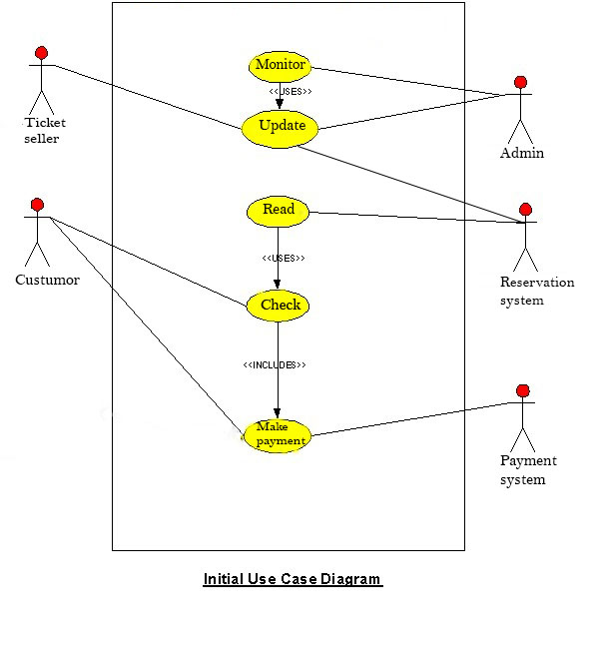

The program flowchart can be simulated as the above graph, how user goes through each stage and actions taken by system according to server response.

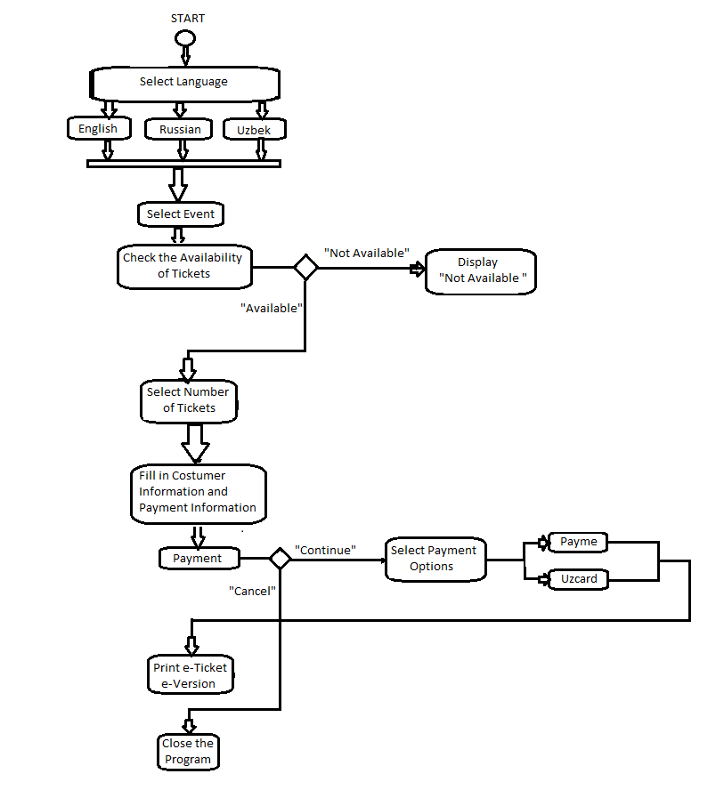

Database Relation of Project:

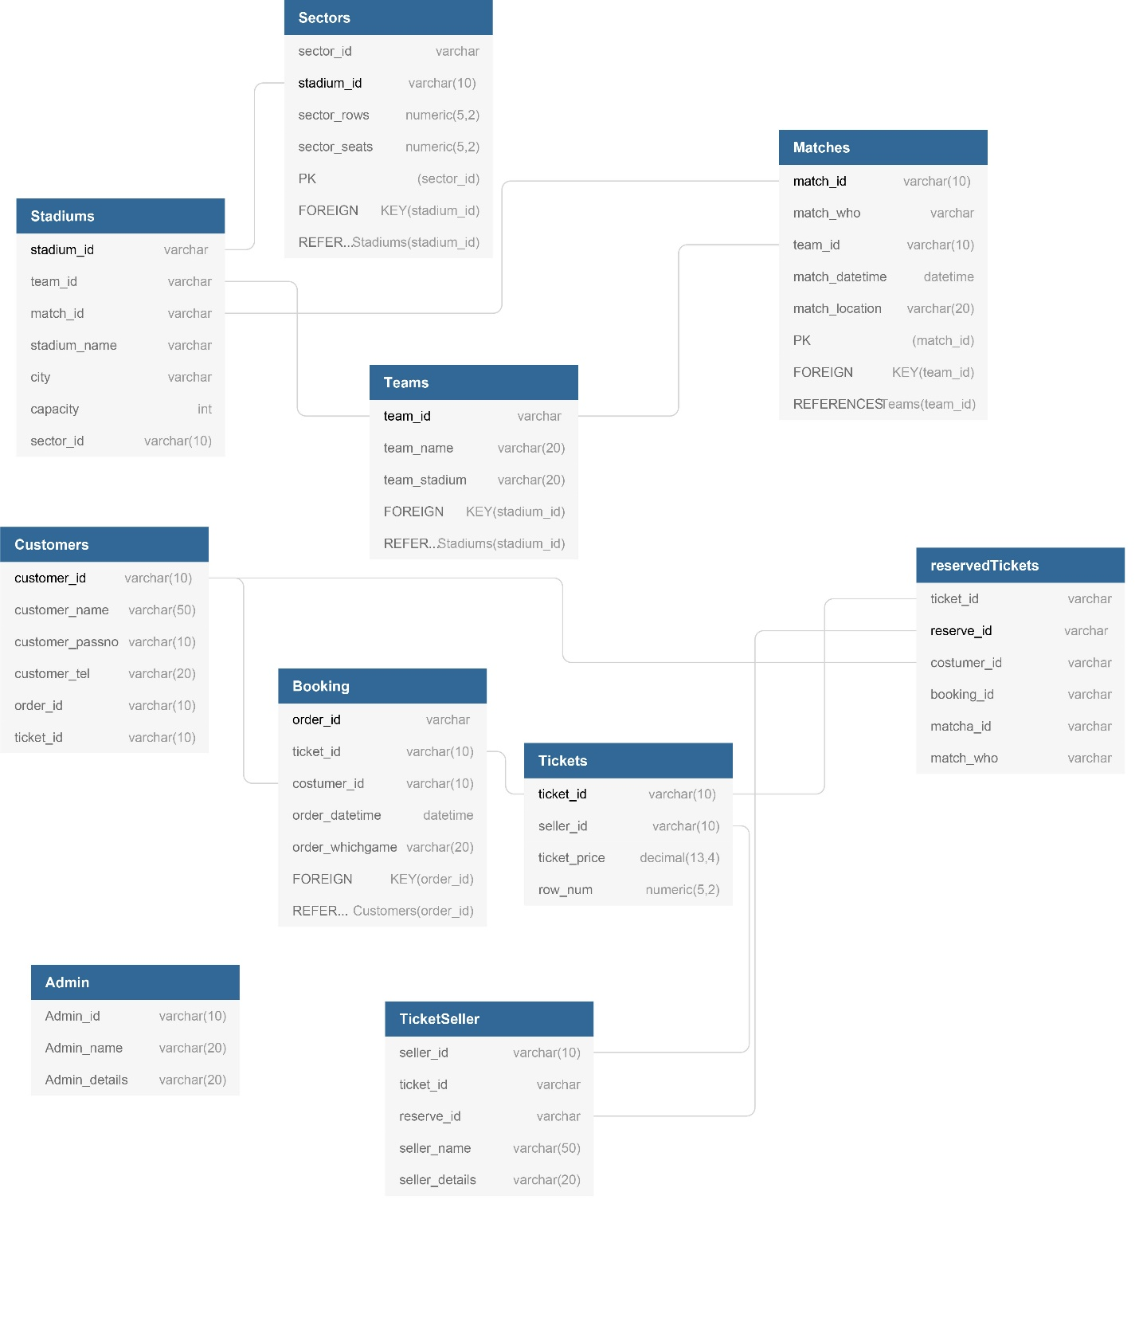

**PROJECT DESIGN AND IMPLEMENTATION:**

The development of application required to use many aspects such as working with databases using MySQL, working with IPC in programming language C and working with GUI using JavaFX programming Languages.

In the program, using Socket Programming we have managed to connect computers and exchange data. In IPC Part, we used c programming language. Using IPC clients can do following tasks:

1. Admin can add and modify ticket reservation data in server from distance
2. Consumers can view the data in database in server
3. Consumers can give request to server to get ticket

We used MySQL for Database Management System. Our Projects Database includes following features:

1. User Information
2. Ticket Information
3. Stadium Information
4. Admins Information
5. Matches Information
6. Payments Information

In GUI part of our project we have used technology called JavaFX. We have created page for admin and user. In admin page admin can do following tasks:

1. Can add or modify matches
2. Keep track of number of seats

In user page user can do following tasks:

1. Can see available tickets and available
2. Order ticket as much as user wants online

**RESULTS & DISCUSSION:**

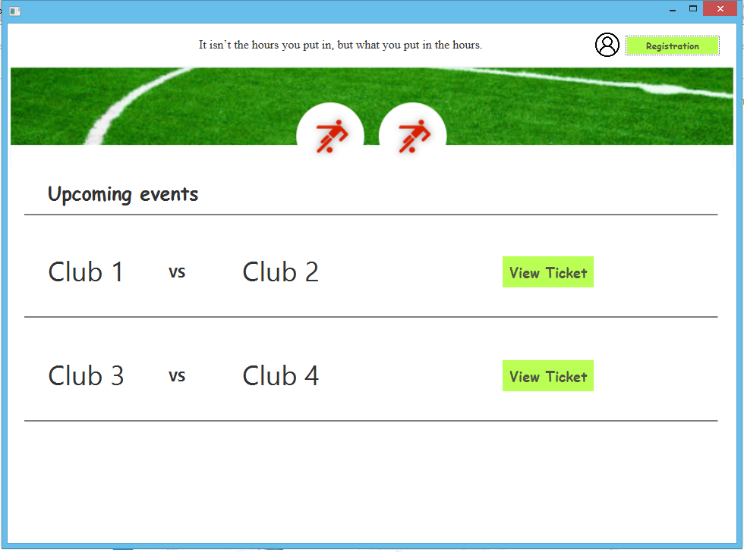

In this page user can see available matches and its price

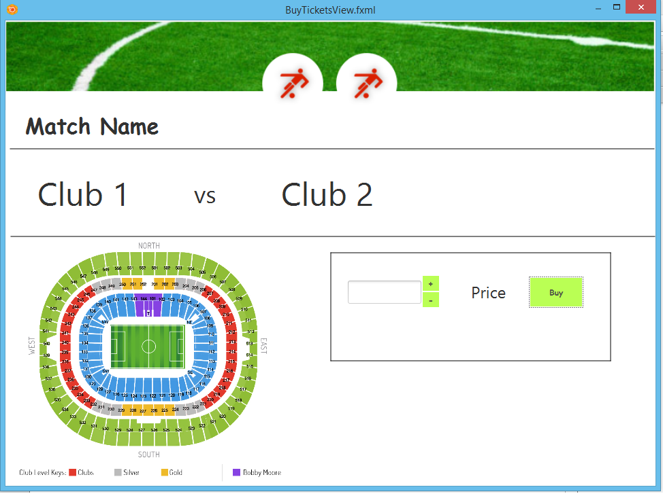

After the selecting match user can buy a ticket and see its price.

**CONCLUSION:**

Using the FTicket-Ticket Reservation system , it is easily possible to book tickets online through the special application that we have developed. The convenience of booking from your home makes online ticket reservation very attractive to the customers. It is predicted that the our ticket reservation system with features such as online reservation and view available tickets, will be used by the vast majority of football clubs and stadiums.

**FUTURE WORK:**

Nowadays, in our project is based on a little number of stadiums. In the future if we increase the number of stadiums consumers will also increase and this makes life easier of costumers.

**REFERENCES :**

1. Introduction to Socket programming in C using TCP /IP, Panagiota Fatourou

2. Understanding the Linux Kernel, Daniel P. Bovet Marco Cesati, ISBN: 0-596-00002-2

3. https://stackoverflow.com.

4.<https://www.ibm.com/support/knowledgecenter/en/SSAL2T_9.1.0/com.ibm.cics.tx.doc/concepts/c_clnt_sevr_model.html>

5. <https://www.geeksforgeeks.org/socket-programming-cc/>

6. <http://www.cs.rpi.edu/~moorthy/Courses/os98/Pgms/socket.html>

7.<http://etutorials.org/Linux+systems/red+hat+linux+9+professional+secrets/Part+I+Setting+Up+Red+Hat+Linux/Chapter+6+Network+Setup/TCP+IP+Services+and+Client+Server+Architecture/>

8. <https://www.tenouk.com/Module40c.html>

9. <https://ops.tips/blog/a-tcp-server-in-c/>

10. <https://www.arsenal.com/tickets>

**PROJECT TEAM :**

**Team Leader :**

**Name Student ID Signature with date**

**1. Shokhrukhmirzo Mirzakhmedov u1610230**

**Team Members :**

**Name Student ID Signature with date**

**2. Abbosjon Kudratov u1610001**

**3. Boburjon Borataliev u1610053**

**4. Aziz Riskulov u1610037**

**5. Azizbek Avazov u1610030**

**6. Mukhammadrasul Mukhtorov u1610156**